**APPLICATION TO ICT**

**Lab Report**



**Name:**

Haseeb Ur Rehman

**Roll no:**

509

**Section:**

M

**Submitted by:**

Haseeb Ur Rehman

**Submitted to:**

Mam Fabia Hasan

**LAB 1**

**Typing Practices and Internal Components**

**Typing Practices:**

There are many websites where we can practice typing. We can master our typing using some software like:

* Typing MasterTyping Study
* Key Blaze

These provide an effective and engaging environment to practice typing.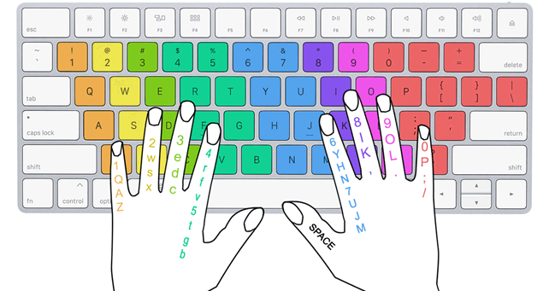

**Internal Components of Computer:**

**Hardware Components:**

* **CPU (Central Processing Unit):** Executes instructions
* **Motherboard:** Connects components
* **RAM (Random Access Memory):** Temporary storage
* **GPU (Graphics processing unit):** Handles graphics
* **Hard drive/SSD:** Permanent storage
* **Power supply:** Provides power
* **Cooling System:** Regulates temperature

**Software Components:**

* Operating System
* BIOS (Basic input/output system)
* Device drivers

**Some Types of These Components:**

* **CPU:** Intel core i5/i7, AMD Ryzen 5/7
* **Motherboard:** ATX, Micro ATX, Mini ATX
* **RAM:** DDR3, DDR4, DDR5
* **GPU:** NVIDIA GeForce, AMD Radeon
* **Hard drive:** HDD, SDD
* **Power Supply:** ATX, SFX, PSU
* **Cooling system:** Air cooling, liquid cooling

**Key Terms [Definitions]:**

**Chipset:** A group of integrated circuits (ICs) that manage data transfer between different components within a computer such as CPU, memory and peripherals.

**BIOS:** Firmware that controls hardware components and initializes system boot-up, allowing the operating system to load.

**Firmware:** Permanent software stored in non-volatile memory devices (e.g., ROM, flash memory) that controls hardware operations.

**Cache:** High-speed memory that stores frequently accessed data, reducing access time and improving system performance.

**Hyper-Threading (Intel) / Simultaneous Multithreading (AMD):** Multicore: A CPU with multiple processing cores increasing processing power and multitasking capabilities.

**Multicore:** A CPU with multiple processing cores increasing processing power and multitasking capabilities.

**LAB 2**

**CPU ASSEMBLING AND WINDOWS INSTALLATION**

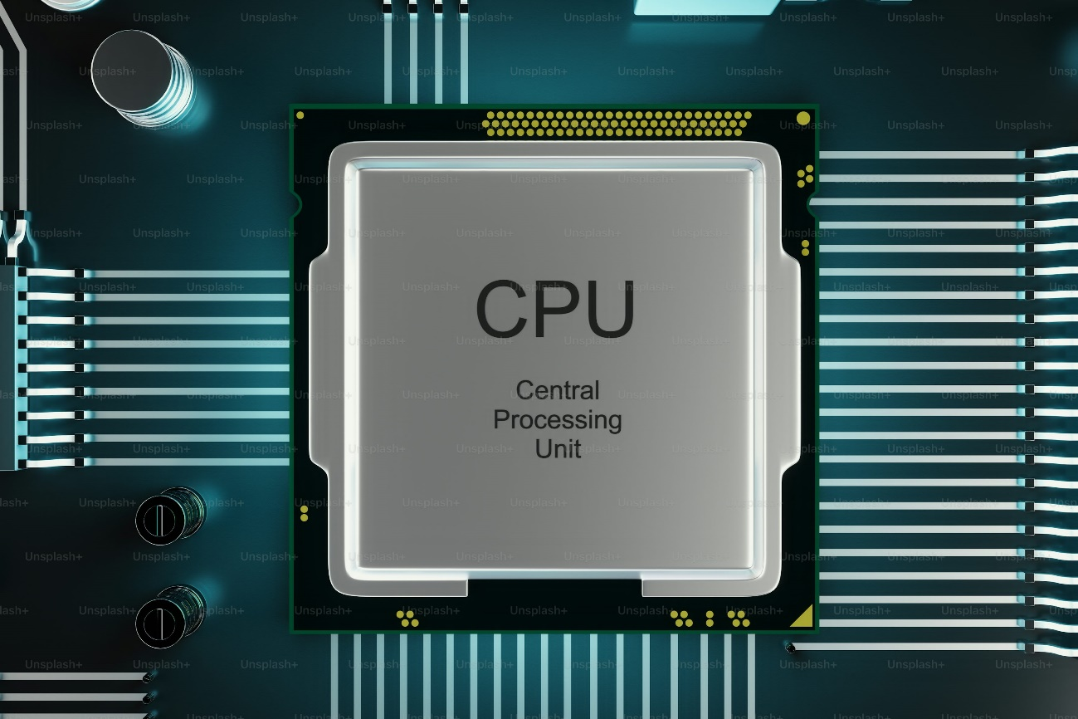

**CPU ASSEMBLING**

**PRE-ASSEMBLY PREPARATION:**

It is necessary to take safety precautions before beginning any work. So:

**1.** Ground yourself to prevent static electricity damage.

**2.** Prepare a clean, flat workspace.

**3.** Unpack and organize components if new.

**COMPONENTS NEEDED:**

CPU

- Motherboard

- RAM (memory)

- CPU cooler (heatsink/fan or liquid cooling)

- Thermal paste

- Mounting hardware

**CPU INSTALLATION:**

**1.** Locate the CPU socket on the motherboard.

**2.** Remove the CPU socket cover.

**3.** Align the CPU with the socket.

**4.** Gently insert the CPU into the socket.

**5**. Secure the CPU with the mounting mechanism.

**CPU COOLER INSTALLATION:**

**1.** Apply thermal paste to the CPU.

**2.** Install the CPU cooler.

**3**. Secure the cooler with mounting hardware.

**RAM INSTALLATION:**

**1.** Locate the RAM slots on the motherboard.

**2.** Align the RAM modules with the slots.

**3.** Insert the RAM modules into the slots.

**4.** Secure the RAM with clips or screws.

**ADDITIONAL CONNECTIONS:**

**1.** Connect the CPU power cable.

**2.** Connect the CPU fan cable.

**3.** Connect any other necessary cables.

**POST-ASSEMBLY CHECKS:**

**1.** Verify CPU installation.

**2.** Check RAM installation.

**3.** Ensure all cables are securely connected.

**4.** Power on the system and test.

**WINDOW INSTALLATION**

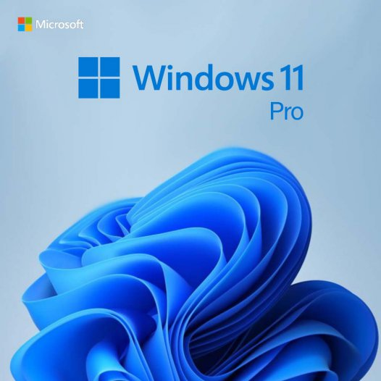

**PRE-INSTALLATION CHECKLIST:**

**1.** Confirm compatible hardware.

**2.** Backup important data.

**3.** Create Windows installation media (USB/DVD).

**4.** Have product key ready.

**INSTALLATION STEPS:**

**Step 1:** **Boot from Installation Media**

**1.** Insert installation media.

**2.** Restart computer.

**3.** Enter BIOS settings (F2, F12, or Del).

4. Set USB/DVD as the primary boot device.

**5.** Save and Exit.

**Step 2:** **Language and Setting**

**1.** Select Language.

**2.** Choose time and currency format.

**3.** Select keyboard layout.

**Step 3:** **Licensing Agreement**

**1.** Read agreement.

**2.** Check "I accept" box.

**3.** Click "Next".

**Step 4:** **Installation Type**

**1.** Choose "Custom" installation.

**2.** Select Drive to install Windows.

**Step 5: Partitioning**

1. Delete existing partition.

**2.** Create new partition.

**3.** Set Partition Size.

**Step 6:** **Installation**

**1.** Click "Next" to start installation.

**2.** Wait for installation.

**Step 7:** **User Account Creation**

**1.** Create a user name.

**2.** Set a password.

**3.** Set security questions.

**Step 8:** **Network Configuration**

**1.** Choose Network type.

**2.** Connect to Wi-Fi or Ethernet.

**Step 9:** **Finalize Installation**

**1.** Review Settings.

**2.** Click "Finish".

**Post-Installation Checklist**

**1.** Install necessary drivers.

**2.** Update Windows.

**3.** Install antivirus software.

**4.** Restore backup data.

**LAB 3**

**MOTHERBOARD AND ITS INTERNAL STRUCTURE**



**MOTHERBOARD:**

The motherboard is the main circuit board of a computer, connecting hardware components.

(Picture)

**Components:**

CPU Socket

2. RAM Slots

3. Chipset

4. PCI/PCIe Slots

5. SATA Ports

6. USB Ports

7. Power Connector

8. BIOS Chip

9. Capacitors

10. Resistors

**NTERNAL STRUCTURE:**

1. CPU Socket: Holds the CPU in place.

2. RAM Slots: Accommodate RAM modules.

3. Chipset: Controls data transfer between components.

- Northbridge: Manages CPU RAM communication. (Picture)

- Southbridge: Handles I/O operations.

4. PCI/PCIe Slots: Expandability for graphic cards, sound cards.

5. SATA Ports: Connect storage devices (HDD, SSD).

6. USB Ports: Connect peripherals (keyboard, mouse).

7. Power Connectors: Receive power from PSU.

8. BIOS Chip: Stores firmware settings.

9. Capacitors: Filter and regulate power.

10. Resistors: Control voltage and current.

**MOTHERBOARD TYPES:**

1. ATX (Advanced Technology Extended)

2. Micro-ATX

3. Mini-ITX

4. Server Motherboards

**MOTHERBOARD FEATURES:**

1. Form Factor

2. CPU Support

3. RAM Capacity

4. Expansion Slots

5. Connectivity Options

6. Power Phases

7. Overclocking Capabilities

**KEYWORDS:**

1. Socket type (LGA, PGA)

2. Chipset (Intel Z390, AMD X570)

3. PCIe (Peripheral Component Interconnect Express)

4. SATA (Serial Advanced Technology Attachment)

5. USB (Universal Serial Bus

6. BIOS (Basic Input/Output System

**LAB 4**

**INTRODUCTION TO MS OFFICE**

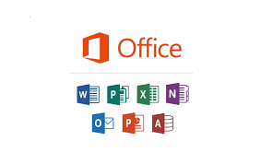

**MS OFFICE:**

MS Office is a suite of productivity software developed by Microsoft, including:

1. MS Word

2. Excel

3. PowerPoint

4. Outlook

5.Access

6. Publisher

**MS WORD:**

MS WORD is an application software of Microsoft. we use this for various purposes.MS WORD is used to make CVs, documents, graphs to manage data and much more.

**FEATURES OF MS WORD:**

1. Document Creation

2. Text Editing

3. Font and Style

4. Alignment & Spacing

5. Cut, Copy, Paste

6. Undo and Redo

7. Save Document (types: .docx, .dotx, .txt, .pdf)

**MS WORD INTERFACE:**

- Quick Access Toolbar

- Title Bar

- Control Box (Minimize, Maximize, Close)

- Document Tabs: File, Home, Insert, Design, Layout, Reference

- Toolbar

- Ribbon

- Vertical Scroll Bar

- Writing Box

- Horizontal Scroll Bar

- Status Bar

- View Button

- Zoom Slider

**SHORTCUTS IN MS WORD:**

**File Operations**

- New: Ctrl + N

- Open: Ctrl + O

- Save: Ctrl + S

- Save As: F12

- Print: Ctrl + P

- Close: Alt + F4

**Quick Access Toolbar**

- Undo: Ctrl + Z

**Clipboard Operations**

- Cut: Ctrl + X

- Copy: Ctrl + C

- Paste: Ctrl + V

**Font Formatting**

- Font face: Ctrl + Shift + F

- Font Style: Ctrl + Shift + P

- Bold: Ctrl + B

- Italic: Ctrl + I

- Underline: Ctrl + U

- Subscript: Ctrl + =

- Superscript: Ctrl + Shift +

1. Grow Font: Ctrl + >

2. Shrink Fon: Ctrl + <

3. Text Effect

4. Text Color

5. Text Highlight Color

6. Change Case

- Lower Case

- Upper Case

- Each Word Capitalized

7. Clear Formatting

**Paragraph:**

Bullets: O, D, Shapes

Numbering: Sequence

Multilevel List: 1, 1.1, 1.2, 1.3

8. Text Alignment

1. Text Align Left : Ctrl + L

2. Text Align Right: Ctrl + R

3. Text Align Centre: Ctrl + E

4. Justify: Ctrl + J

5. Border

6. Line Spacing

7. Shading

9. Sort:

- i) Ascending

- ii) Descending

10. Show / Hide

Style:

1. Find: Ctrl + F

2. Replace: Ctrl + H

**LAB 5**

**ADVANCED FEATURES OF MS WORD**

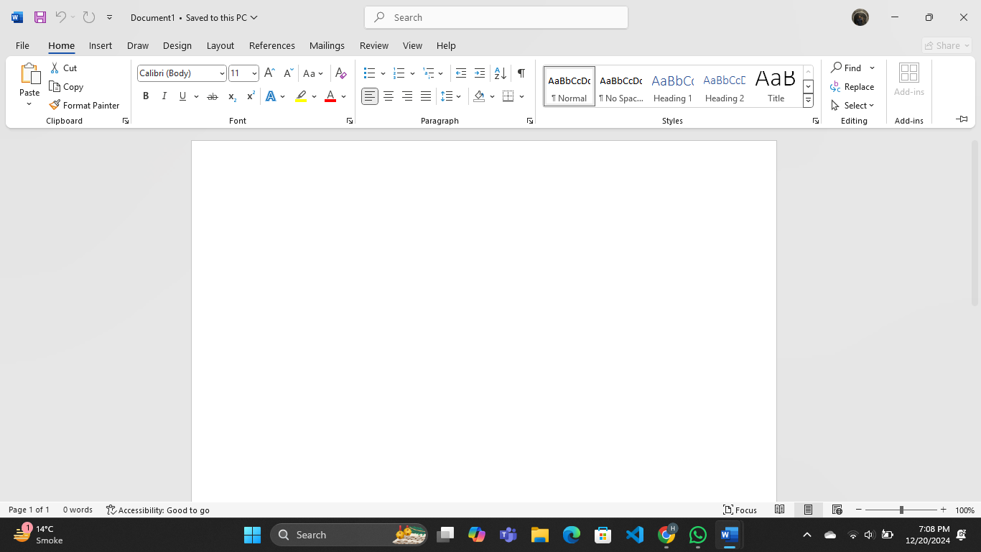

**PAGES:**

1) Page break

2) Blank page

3) Cover page

**TABLES:**

1) Insert Table

**ILLUSTRATOR:**

1) Picture

2) Shapes

3) Smart Art

4) Chart

5) Screenshot

6) Clips

**SIZE OF HEADING/BODY (FONT):**

- Heading: 14-16

- Body: 11-13

**EXCEL:**

Excel is used for E. Bills, Tables, number Result card.

Next -

- Cell: no of one column & no. of Row

- Active cell: Where the cursor is

- Over all page called: Separate Sheet

- Range: group of rows and columns

**MAILING**

**Steps of Mail Merge:**

1. Open MS Word.

2. Click on Mailings

3. Start Mail Merge -> Step by Step Mail Merge.

4. Select Document Type (Step 1).

5. Click on Selecting Starting Document (Step 2).

6. Click on Select Recipients -> Type a New List.

7. Create a New List.

8. Fill or leave blank the recipient information in the table.

9. Add a new row if needed.

10. Enter different data in each row.

11. Click on Customize Address List (to delete existing data or add new data).

12. Click OK and save it with a desired name on your PC.

13. Use the Find Recipient option in the previous popup after saving to select the recipient to whom you want to send data.

14. Click on Step 4 in the bottom right corner.

15. Click on More Items to add desired fields like:

- Title

- First name, last name

- Company name

- City

16. Click on Step 5 → Do your desired operation

17. Click on Step 6 → Do your desired operation

18. =rand ()

**MAKE AUTOMATIC HEADINGS**

To write the content or heading in the top, like an introduction of every topic:

Write a heading for every topic on the first page.

1. Open MS Word

2. Click on Reference

3. Click on Table of Contents

**Page Layout:** Click on Columns → Page Break

**In (Insert):** Add Header, Footer, Number

**LAB 6**

**MENDELEY, REFERENCE LINKS AND MUCH BASIC TASKS**

**TO INSERT A FOLDER:**

1. Open MS Word

2. Go to Insert

3. Click on Link

4. Click on the Folder/Browse page

5. Select the Folder

6. Click OK

7. A link will be generated in the current MS Word document

8. To open that link, press Right click + Ctrl

- The particular file will open.

**TO INSERT AND MARK A TOPIC OR SOME DATA TO ADD A SIGN (BOOKMARK) FROM WHERE WE CAN QUICKLY NAVIGATE TO THAT PARTICULAR PAGE:**

1. Open MS Word

2. Click on Insert

3. Click on Bookmark [Select the pre-written data that should be marked]

4. Add your desired name for that topic

5. Write the name and click OK

6. Now you can navigate to the desired section by clicking on that Bookmark.

**CROSS REFERENCE:**

1. Open MS Word

2. Click on Insert

3. Click on Cross-reference

**CITATIONS & BIBLIOGRAPHY**

click on References next to the Insert menu and find - Insert Citations & Bibliography

**MACROS: TO RECORD OUR WORK DOING ON MS WORD**

- It can only record actions performed using the keyboard.

File -> More -> Options -> to change settings and colors.

**MENDELEY: USED FOR PAGE CITATION**

I Love PDF website name to convert PDF to DOC, Word, Excel, and PowerPoint.

TO CORRECT SPELLING:

1. Click on Review

2. Click on Spelling & Grammar

**TO ADD AN ENDNOTE/FOOTNOTE:**

1. Open MS Word

2. Click on Reference

3. Now you will see the tab

**TO DELETE A PAGE:**

- Open WhatsApp

- Search "how to delete a page on MS Word" in WhatsApp

- See the steps and delete it.

**LAB 7**

**Mail managements, Collaborative Tools & Document Protection, (Track changes and comments for collaborative work, Master reviewing and comparing documents, protect documents with passwords and control editing permissions):**

**I) MAIL MANAGEMENT:**

1. Email integration: Yes (via Outlook)

2. Email templates: Yes (via Outlook)

3. Email tracking: No (but available in Outlook)

**II) COLLABORATIVE TOOLS:**

1. Co-authoring: Yes (real-time collaboration)

2. Track changes: Yes (Tools > Track Changes)

3. Comments: Yes (Insert > Comment)

4. Share document: Yes (File > Share)

**III) DOCUMENT PROTECTION:**

1. Password protection: Yes (File > Info > Protect Document > Encrypt with password)

2. Editing Permission: Yes (File > Info > Protect Document > Restrict Editing)

3. Digital Signature: Yes (File > Info > Protect Document > Add a Digital Signature)

**IV) TRACK CHANGES AND COMMENTS:**

1. Insert Comment: Right-click > Insert Comment or Review > New Comment

2. Track changes: Tools > Track Changes or Review > Track Changes

3. Accept/Reject changes: Review > Accept or Reject Changes

4. Compare documents: Review > Compare

**V) MASTER DOCUMENT REVIEWING:**

1) Reviewing pane: Review > Reviewing pane

2) Document inspection: File > Info > Check for issues

3) Document protection: File > Info > Protect Doc

4) Versioning: File > Info > Version History

**VI) DOCUMENTS PROTECTION WITH PASSWORDS:**

1) Encrypt document: File > Info > Protect Doc > Encrypt with password

2) Set editing permissions: File > Info > Protect Doc > Restrict Editing

3) Digital Signatures: File > Info > Protect Doc > Add a Digital Signature

Available in 2010, 13, 16, 19, Office 365

**SHORTCUT KEYS OF EXCEL:**

**Navigation:**

Ctrl + ↑ = for upper cell in column

Ctrl + ↓ = for lower cell in column

Ctrl + → = for rightmost cell in row

Ctrl + ← = for leftmost cell in row

**Row operations:**

i) Insert Row: Ctrl + (+) (3)

ii) Delete Row: Ctrl + (-) (2)

iii) Select entire Row: Shift + Space bar (1)

**Column operation:**

i) Insert Column: Ctrl + (+)

ii) Delete column: Ctrl + (-)

iii) Select column: Ctrl + Space bar

Ctrl + G < Special > (delete column up)

**Cell operations:**

1. Merge cells: Ctrl + M

2. Unmerge cells: Ctrl + Shift + M

3. Alt + H + M + C -> to add a cell/merge cell

4. Split cell: Ctrl + Shift + T

5. Insert time: Ctrl + Shift + ( ; )

6. Insert date: Ctrl + ( ; )

7. Insert timestamp: Ctrl + Shift + !

**Editing:**

- Cut: Ctrl + X

- Copy: Ctrl + C

- Paste: Ctrl + V

- Undo: Ctrl + Z

- Redo: Ctrl + Y

**Selection:**

- Select All: Ctrl + A

- Select entire table: Ctrl + A (twice)

- Select range: Ctrl + Shift + Space bar (then select range)

**LAB 8**

**MS Excel**

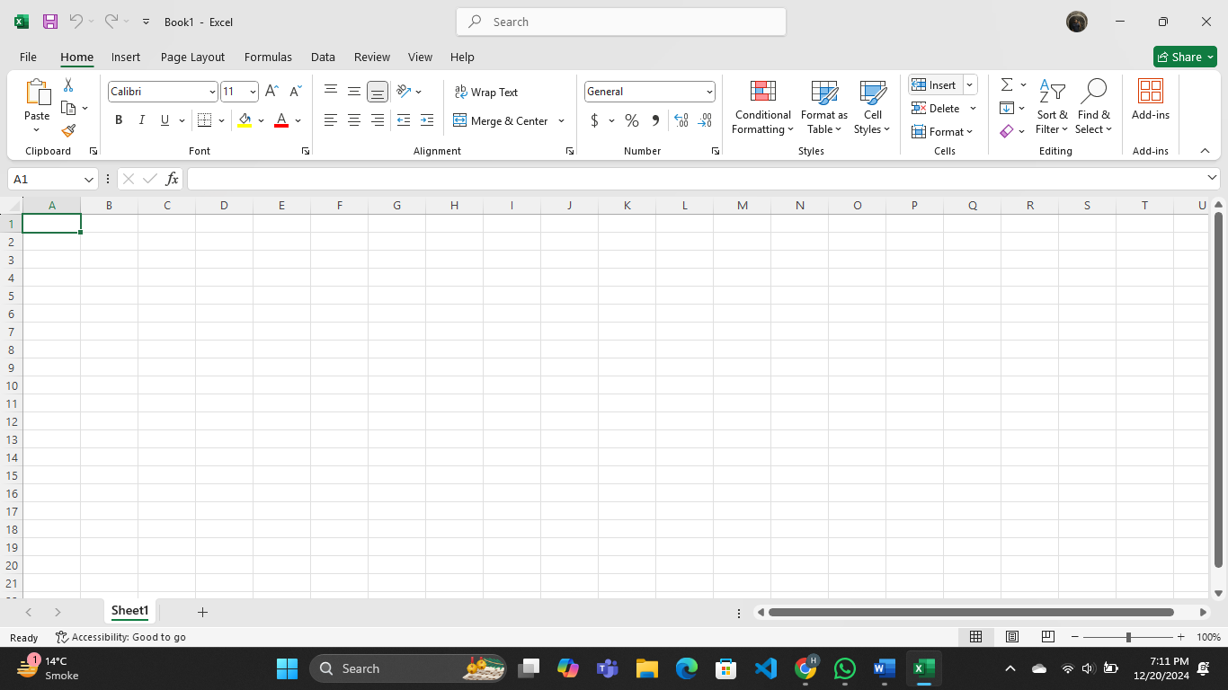

**FORMULAE:**

We will read formulae write the formulae in upper case.

**I) SUM FORMULAE**

To Sum all Values

1. Select all values & press [Alt + =] to add them

2. To add them: Select a cell, put = then press Shift and write SUM and then select our cells to be added by dragging and then close the bracket and press enter, and it will sum all values.

- In short, =SUM (cells selected)

**II)PRODUCT FORMULAE**

To product all values as selected

= PRODUCT (selected cells) press enter.

**III)PROPER**

To Proper

=PROPER (select cell) press enter

Proper means to make the first letters of the selected word capital and others small, like "hello world" will become "Hello World."

➢ to fit the cell according to data entered (lower left corner right click)

“Cells.EntireColumn. AutoFit”

**IV) MAX FORMULAE**

To Find Max value

=MAX (Select cells) press enter

**V) MIN FORMULAE**

To Find Min value

=MIN (Select cells) press enter

**VI) LARGE NUMBER FINDER**

Find Large number you want

In this we find the large numbers like 1st large means largest among them, 2nd large means 2nd

larger number.

Syntax:

=LARGE (Select cells, 1st or 2nd or 3)

**VII) TO ADD DATE**

To add current date

=TODAY ()

To add yesterday's date or whatever we want

=TODAY ()-1 or -2 or -3....

To add tomorrow's date or more

=TODAY ()+1 or +2 or...

**VII) TO ADD TIME**

=TIME (hour, min, sec)

**VIII) NOW FORMULAE**

To add current date and time

=NOW () Used to return current date and time.

**IX) LEN FORMULAE**

To Count the digits

=LEN (selected cell)

**X) COUNT FORMULAE**

To count the numbers only from the whole selected text

=COUNT (selected value)

**XI) COUNTA FORMULAE**

To count all cells or values

=COUNTA (selected value)

**XII) COUNTBLANK**

To count the number of blanks:

=COUNTBLANK (range)

**XIII) CONCATENATE FORMULAE**

To write the separate name without copying:

=CONCATENATE (select 1, " ", select cell)

**XIV) SUMPRODUCT**

To add SUMPRODUCT:

=SUMPRODUCT (select cells)

**XV) COUNTIF**

To add COUNTIF

=COUNTIF ("select row", "p")

- It is used as condition count the number if the condition meets.

- We use COUNTIF to count all the terms like "p" come in this row.

**XVI) TO CONVERT THE NUMBER TO ROMAN**

=ROMAN (selected row)

**XVII) AVERAGE**

To find average

=AVERAGE (select cells)

**XVIII) PERCENTAGE**

To find percentage

=Part/Total 100

**LAB 9**

**MS Excel Advance**



**BAR CODE TO HIDE INFORMATION:**

1. Select cell

2. Format clicks

- Select Row and Column width from format in first home menu

3. Write text in first cell 123 |||||

4. Write formula: = “& [selected cell] &”

5. Select the cell 2nd cell in which there is formula written

6. Go to font

7. Search [Libre Barcode 39]

8. Click on it.

**QR CODE AS A LINK URL:**

1. Select cell, go to format, give length, width to rows, columns respectively

2. Now write YouTube or whatever you want to create QR.

3. Now go to left upper corner to Add-ins and add QR Code Shortcut

Use the shortcut to create QR and paste it in the sheet simple. ✔

Snipping tool to take screenshot.

**Lab 10**

**Advance MS Excel**



**Objective**

The objective of this lab report is to explore and understand the application of advanced Excel functions—specifically VLOOKUP, HLOOKUP, INDEX-MATCH, and other related tools—for efficiently managing, analyzing, and retrieving data in real-world scenarios. These functions are widely used in various fields including business, finance, research, and project management for tasks involving large datasets, lookups, and complex data analysis. By understanding these tools, users can enhance their ability to handle data more effectively and improve decision-making processes.

**Introduction**

Excel is a powerful tool used extensively for managing, analyzing, and visualizing data. While basic Excel functions help with simple tasks, advanced functions like VLOOKUP, HLOOKUP, and INDEX-MATCH become essential when working with complex datasets, especially in final projects or large-scale data analysis. These functions allow users to search for specific data points across multiple tables, perform lookups in both vertical and horizontal directions, and retrieve relevant information from large sets of data.

VLOOKUP and HLOOKUP are two of the most commonly used lookup functions in Excel, while the combination of INDEX and MATCH offers a more flexible and robust alternative for handling data searches. Mastering these functions is crucial for anyone involved in data analysis, as they form the foundation for various operations such as reporting, financial analysis, inventory tracking, and more.

This lab will investigate these advanced Excel tools in detail, with a focus on how they are used to streamline data management and enhance data analysis.

**Materials and Tools**

* Microsoft Excel (any version from 2016 or later)
* Sample dataset (such as a table of employee records, sales data, or inventory items)
* Basic knowledge of Excel formulas and functions

**Methodology**

The following advanced Excel functions were analyzed in this report: VLOOKUP, HLOOKUP, INDEX, MATCH, and their combinations. The methodology involved:

1. **Exploring VLOOKUP:**
   * Understanding its application for vertical lookups in a table.
   * Demonstrating its usefulness in retrieving information such as product prices, employee details, or sales figures based on a specific search criterion.
2. **Exploring HLOOKUP:**
   * Exploring its functionality for horizontal lookups in tables.
   * Comparing it to VLOOKUP and identifying when it is more appropriate to use HLOOKUP over VLOOKUP.
3. **Combining INDEX and MATCH:**
   * Analyzing the INDEX and MATCH combination as a more flexible alternative to VLOOKUP and HLOOKUP.
   * Understanding how INDEX and MATCH can handle complex data searches and retrieval tasks, even when the lookup value is not in the first column or row.
4. **Use Cases:**
   * Applying these functions to real-world scenarios, such as looking up employee information in a database, searching for sales figures by month, or finding specific product details based on an identifier.

**Results**

**1. VLOOKUP Function**

The VLOOKUP function is a vertical lookup function used to find a value in the first column of a table and return a corresponding value from another column in the same row. In this lab, we demonstrated how VLOOKUP can be used to find specific employee details, such as name or salary, by searching for the employee’s unique ID number. It is important to note that VLOOKUP is limited by the fact that it can only search for data in the first column and return results from columns to the right.

**For example, searching for an employee’s salary by employee ID is a common use case for VLOOKUP.**

**2. HLOOKUP Function**

The HLOOKUP function, on the other hand, is a horizontal lookup function used to search for a value in the first row of a table and return a corresponding value from another row. This is particularly useful when data is organized horizontally rather than vertically. In our experiments, we demonstrated HLOOKUP to retrieve monthly sales data for a specific product by searching for the month in the top row and returning the sales data from the corresponding row below.

**3. INDEX-MATCH Combination**

The combination of INDEX and MATCH offers a more powerful and flexible alternative to VLOOKUP and HLOOKUP. While VLOOKUP and HLOOKUP are limited in terms of lookup direction and flexibility, INDEX and MATCH allow for both horizontal and vertical lookups, enabling users to perform more complex data retrieval tasks. The MATCH function searches for the position of a specified value in a range, while the INDEX function returns the value at a specific position in a table or range.

In this report, we demonstrated how INDEX and MATCH can be used to search for a specific employee's details, regardless of the column they are located in. The flexibility of INDEX and MATCH makes it especially valuable in large datasets where the data structure may not be uniform or where the lookup value is not positioned in the first column or row.

**Discussion**

The VLOOKUP and HLOOKUP functions are essential for basic lookup tasks where data is organized in a predictable and structured manner. However, these functions have certain limitations:

* VLOOKUP can only search in the first column of the table, which restricts its flexibility.
* HLOOKUP is similarly limited to searching in the first row of the table.

In contrast, the combination of INDEX and MATCH offers much greater flexibility. INDEX and MATCH allow users to search in any column or row, and the retrieval of data is not constrained by the position of the lookup value. This makes INDEX and MATCH ideal for scenarios where the data structure is complex or where the lookup value is not positioned at the beginning of the table.

The INDEX-MATCH combination also improves efficiency, particularly with large datasets. Unlike VLOOKUP, which searches the entire table from top to bottom, INDEX-MATCH searches only the relevant range, often resulting in faster calculations.

However, the main downside of using INDEX and MATCH is its complexity compared to the simpler VLOOKUP and HLOOKUP functions. While VLOOKUP and HLOOKUP are easier for beginners to understand and implement, INDEX-MATCH requires a better understanding of how both functions work together.

**Applications**

**The advanced lookup functions analyzed in this report have numerous practical applications:**

* Business Analysis: In a business context, VLOOKUP and HLOOKUP can be used to retrieve financial data, such as revenue, expenses, or product prices. INDEX-MATCH is ideal for complex financial models, where data might not always be arranged in a simple tabular format.
* Project Management: In project management, these functions can be used to look up project details such as budget allocations, team assignments, or deadlines from large project data tables.
* Inventory Management: VLOOKUP, HLOOKUP, and INDEX-MATCH can be employed to track inventory, where users can quickly find details such as product descriptions, stock levels, or prices.
* Human Resources: In HR, these functions are widely used to look up employee records, including personal information, salaries, positions, and performance metrics.

**Lab 11**

**Pencil**



**Introduction to Pencil (Software)**

Overview: Pencil is an open-source software for creating hand-drawn animations and illustrations. It is suitable for both beginners and experienced animators, providing tools for drawing, sketching, and animating.

**Key Features:**

1. **Drawing Tools:**
   * Pencil and Brush Tools: Various brushes and pencils for drawing and sketching.
   * Eraser: Tools for correcting mistakes and refining drawings.
2. **Layers and Frames:**
   * Layers: Separate different elements of a drawing to manage them independently.
   * Frames and Timeline: Create frame-by-frame animations and manage the timeline.
3. **Color and Fill:**
   * Color Palette: Choose from a range of colors for drawing and filling.
   * Fill Tool: Quickly fill areas with color.
4. **Animation:**
   * Frame-by-Frame Animation: Create animations by drawing individual frames.
   * Onion Skinning: View multiple frames at once to ensure smooth transitions.
5. **Export and Sharing:**
   * Export Formats: Save animations and illustrations in various formats, including PNG, GIF, and SVG.
   * Sharing Options: Easily share creations with others or publish them online.

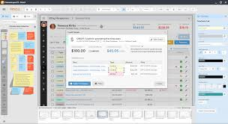

**Lab 12**

**Adobe Illustrator**



**Introduction to Adobe Illustrator**

Overview: Adobe Illustrator is a professional vector graphics software used by designers and artists to create scalable graphics, illustrations, logos, and complex artwork. It is known for its precision and versatility.

**Key Features:**

1. **Drawing and Illustration:**
   * Pen Tool: Allows for precise drawing of vector paths and shapes.
   * Brushes: A variety of brushes for creating unique strokes and textures.
2. **Vector Graphics:**
   * Scalable Artwork: Vector graphics can be resized without losing quality.
   * Pathfinder and Shape Builder Tools: Combine, divide, and manipulate shapes to create complex designs.
3. **Typography:**
   * Advanced Text Features: Access to a wide range of fonts and text manipulation tools.
   * Text on a Path: Create text that follows the shape of a path or object.
4. **Color and Gradient:**
   * Color Management: Use swatches, color guides, and palettes for consistent color schemes.
   * Gradient and Mesh Tools: Create smooth color transitions and gradients.
5. **Layers and Artboards:**
   * Layers: Organize artwork by layers for easier editing and management.
   * Artboards: Multiple artboards allow for working on different pieces of a project within a single document**.**

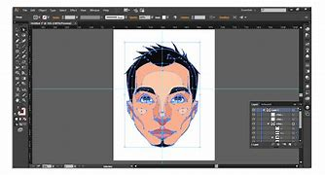

**Lab 13**

**Canva**



**Introduction to Canva**

Overview: Canva is a user-friendly graphic design tool that allows users to create professional-quality designs with ease. It is widely used for creating social media graphics, presentations, posters, documents, and other visual content.

**Key Features:**

1. **Templates and Layouts:**
   * Pre-designed Templates: Canva offers a vast library of customizable templates for various design needs.
   * Drag-and-Drop Interface: Users can easily add elements to their designs by dragging and dropping them onto the canvas.
2. **Elements and Graphics:**
   * Graphics and Icons: Canva provides a collection of icons, shapes, and illustrations to enhance designs.
   * Photos and Videos: Access to a wide range of stock photos and videos for use in designs.
3. **Text and Fonts:**
   * Customizable Text: Add and modify text with various fonts, sizes, and colors.
   * Text Effects: Apply effects like shadows, outlines, and spacing adjustments to text.
4. **Collaboration:**
   * Real-Time Collaboration: Multiple users can work on a design simultaneously, making it ideal for team projects.
   * Comments and Feedback: Team members can leave comments and feedback directly on the design.

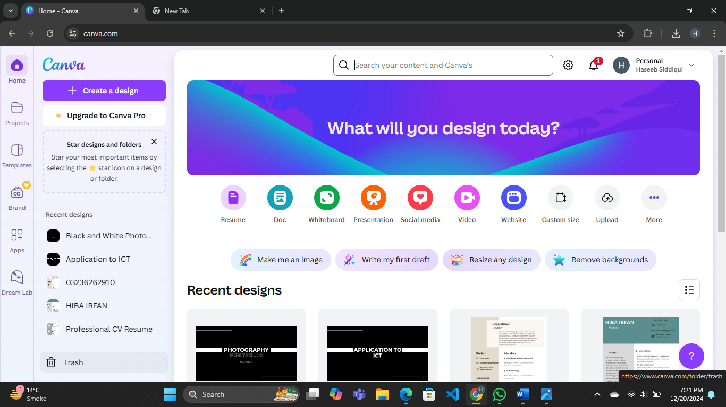

**Lab 14**

**Git Hub**



**A Quick Guide to GitHub**

GitHub is a popular platform for version control and collaborative software development. It provides tools to streamline project management, code sharing, and teamwork. Here's a concise overview of its key features and benefits:

**1. What is GitHub?**

* A cloud-based platform for managing Git repositories.
* Supports version control, making it easier to track and manage code changes.
* Used for collaborative development among individuals and teams.

**2. Key Features**

* Repositories (Repos): Storage spaces for projects, including code, documentation, and files.
* Branching: Enables users to create separate versions of a project for experimentation.
* Pull Requests (PRs): Allows contributors to propose changes and request reviews.
* Issues: A tool for tracking bugs, enhancements, and tasks.
* Actions: Automates workflows such as testing, deployment, and continuous integration (CI).
* Wiki: A built-in feature for documentation and project information.

**3. Benefits of Using GitHub**

* Facilitates collaboration with team members worldwide.
* Provides robust version control for tracking code changes over time.
* Hosts both public and private repositories.
* Integrates with various tools and services like CI/CD pipelines.
* Offers a user-friendly interface for managing projects.

**4. Getting Started**

* Sign up for a free GitHub account at [github.com](https://github.com/).
* Create a new repository to start a project.
* Use Git commands to manage your repository locally.
* Push changes to GitHub for versioning and collaboration.

**5. Best Practices**

* Use clear commit messages to explain changes.
* Create branches for feature development or bug fixes.
* Regularly merge branches to keep the main codebase updated.
* Review and test code thoroughly using PRs before merging.
* Leverage GitHub Actions for automation and productivity.

**6. Popular Use Cases**

* Open-source software development.
* Collaborative academic or research projects.
* Managing personal projects and portfolios.
* Tracking software bugs and features.

